PROJECT 2 AIRCARGO
- IMPORTED DATA

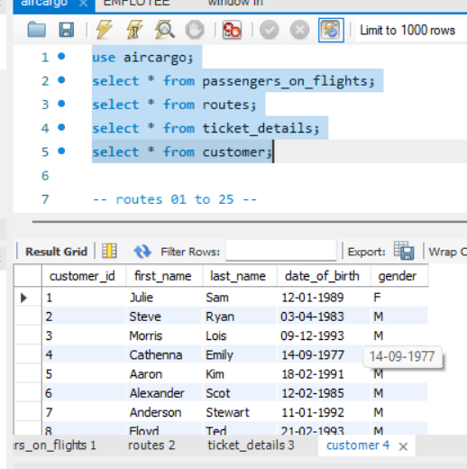
- E-R DIAGRAM
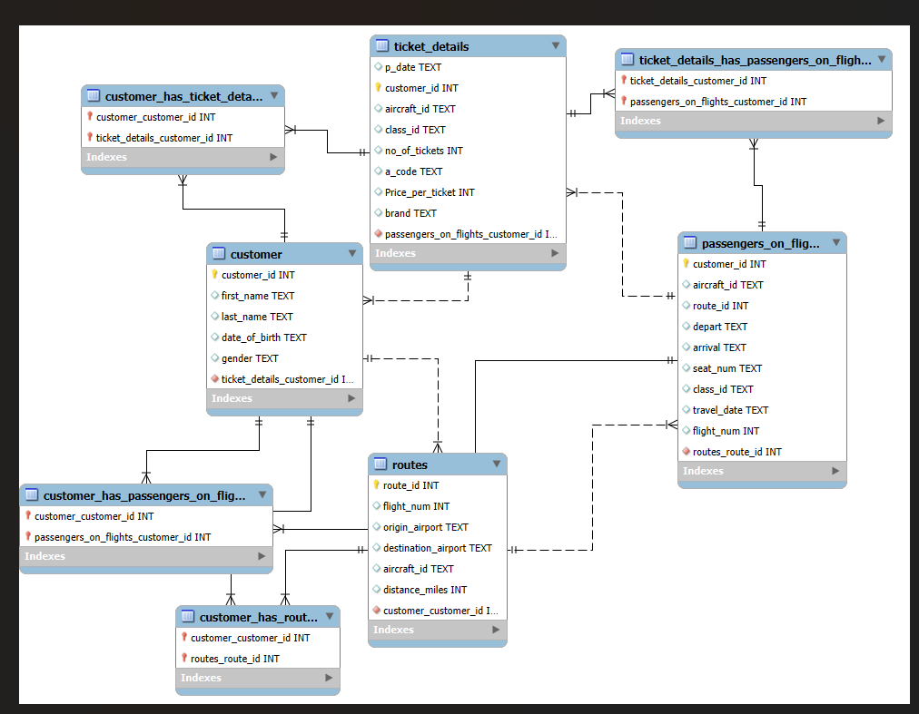

- Write a query to display all the passengers who have traveled on routes 01 to 25 from the passengers_on_flights table.

SELECT *
FROM passengers_on_flights
WHERE route_id BETWEEN '01' AND '25';
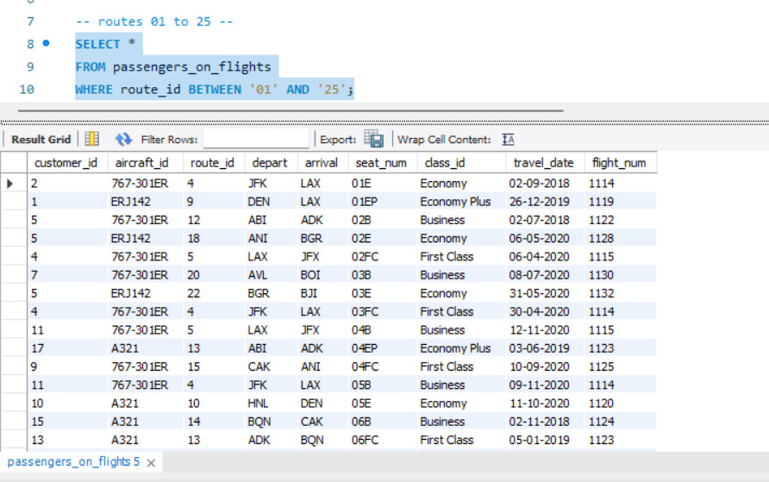

- Write a query to identify the number of passengers and total revenue in business class from the ticket_details table.

SELECT
SUM(no_of_tickets) AS tatal_buisness_tickets,
SUM(price_per_ticket * no_of_tickets) AS total_revenue_business
FROM ticket_details
WHERE class_id = 'Business';
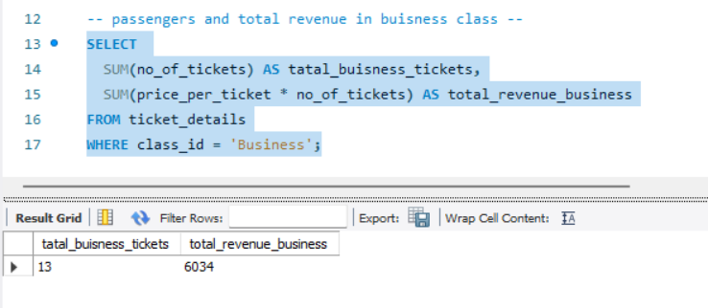
- Write a query to display the full name of the customer by extracting the first name and last name from the customer table.

select concat(first_name,last_name) as full_name
from customer;
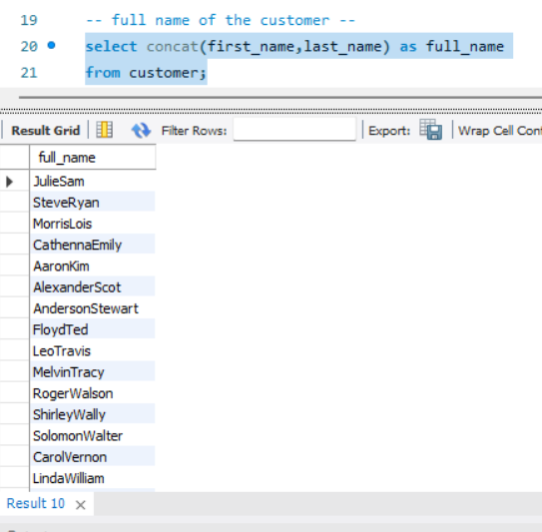

- Write a query to extract the customers who have registered and booked a ticket from the customer and ticket_details tables.

SELECT DISTINCT c.customer_id
FROM customer AS c
inner JOIN ticket_details AS td
ON c.customer_id = td.customer_id;
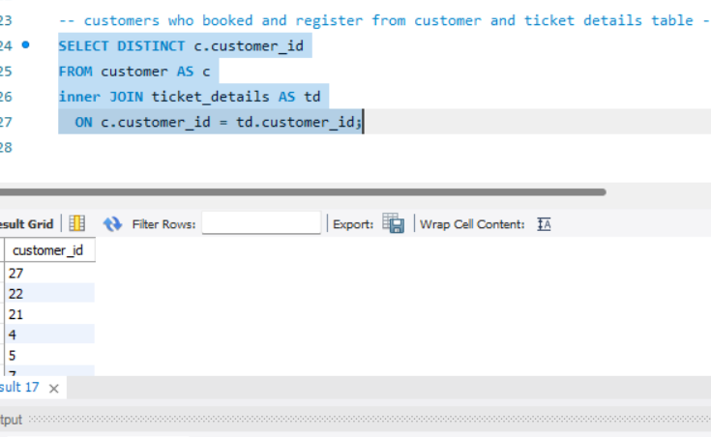
- Write a query to identify the customer’s first name and last name based on their customer ID and brand (Emirates) from the ticket_details table.

select td.customer_id, td.brand, c.first_name, c.last_name
from ticket_details as td, customer as c
where td.customer_id = c.customer_id
having brand = "emirates";
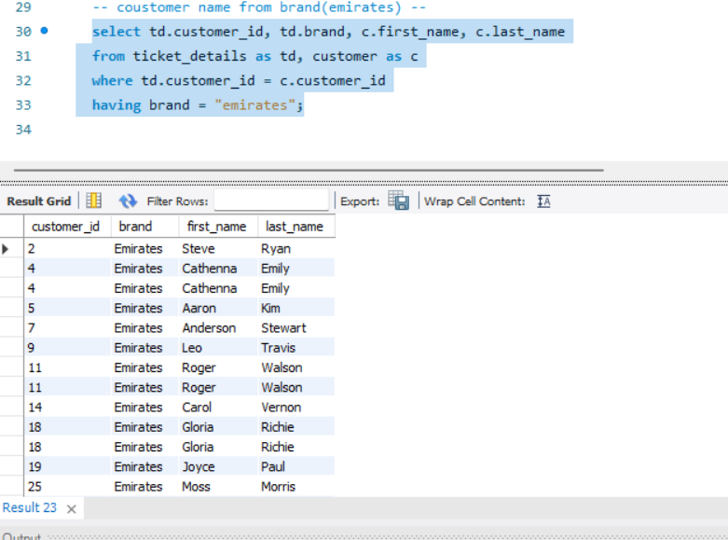

- Write a query to identify the customers who have traveled by Economy Plus class using the sub-query on the passengers_on_flights table.
SELECT *
FROM customer AS c
WHERE c.customer_id IN (
SELECT p.customer_id
FROM passengers_on_flights AS p
WHERE p.class_id = 'Economy Plus');
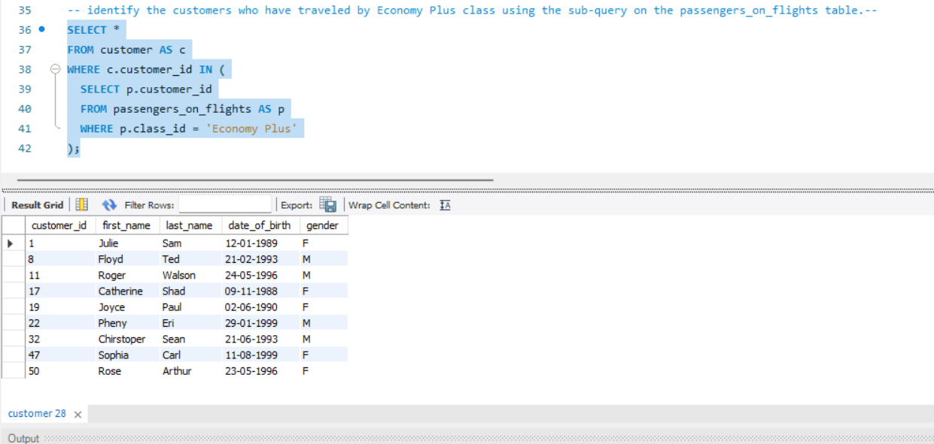

- Write a query to determine whether the revenue has crossed 10000 using the IF clause on the ticket_details table.

SELECT
SUM(no_of_tickets * price_per_ticket) AS total_revenue,
IF(SUM(no_of_tickets * price_per_ticket) > 10000,
'Yes, revenue crossed 10000',
'No, revenue did not cross 10000') AS irevenue_threshold
FROM ticket_details;
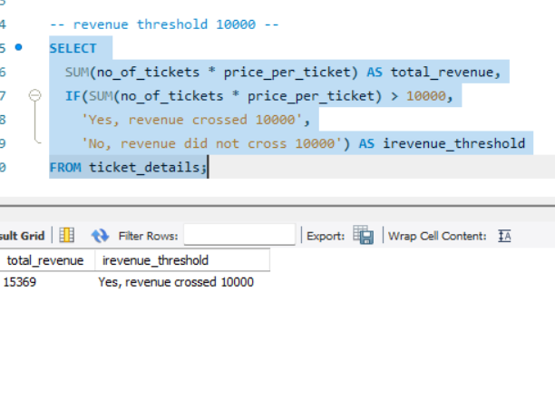
- Write a query to create and grant access to a new user to perform database operations.

CREATE USER 'new_user'@'localhost' IDENTIFIED BY 'Your$tr0ngP@ssw0rd';
GRANT SELECT, INSERT, UPDATE, DELETE, CREATE, DROP
ON aircargo.*
TO 'new_user'@'localhost';
FLUSH PRIVILEGES; 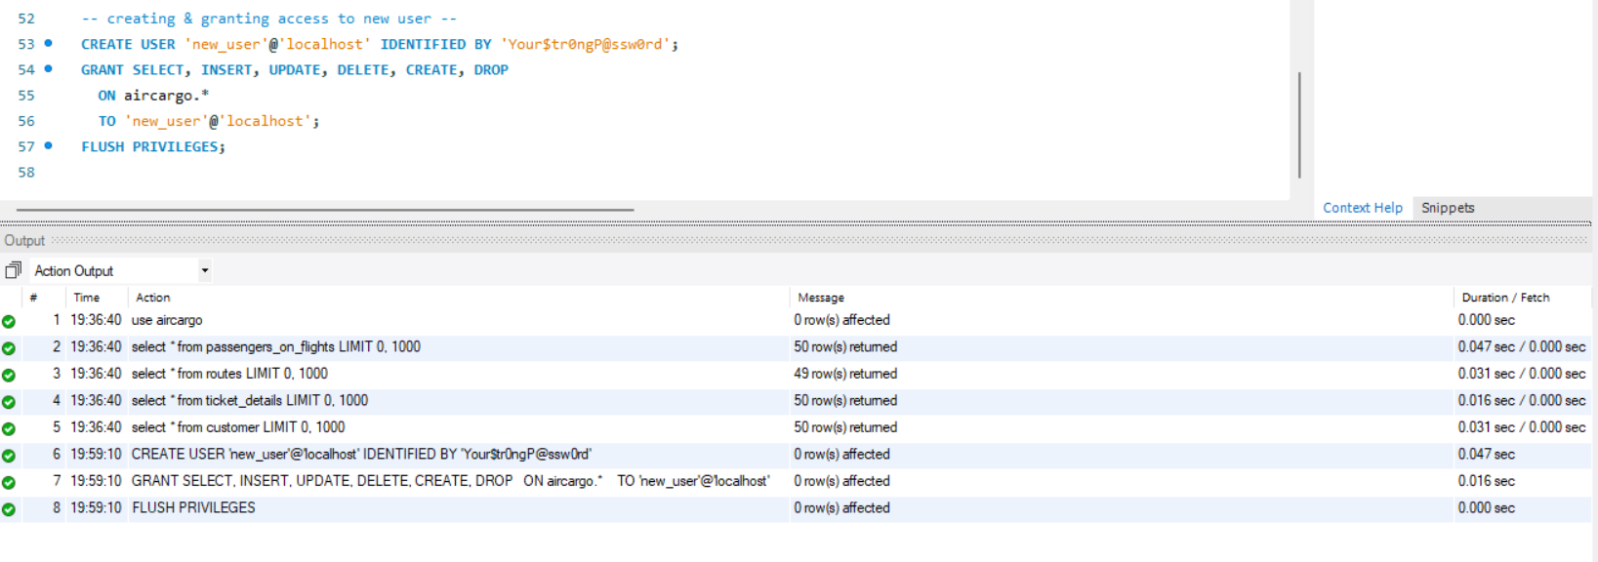
SHOW GRANTS FOR 'new_user'@'localhost';
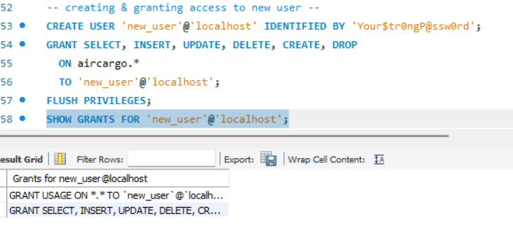

- Write a query to find the maximum ticket price for each class using window functions on the ticket_details table.
select price_per_ticket, class_id,
max(price_per_ticket) over(partition by class_id) as max_price
from ticket_details;

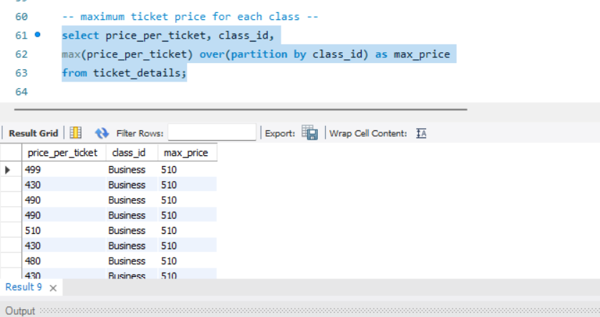
- Write a query to extract the passengers whose route ID is 4 by improving the speed and performance of the passengers_on_flights table using the index.
CREATE INDEX idx_route_id ON passengers_on_flights(route_id);
SELECT *
FROM passengers_on_flights
WHERE route_id = 4;
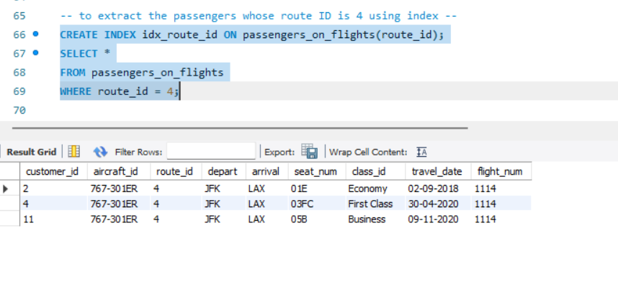

- For route ID 4, write a query to view the execution plan of the passengers_on_flights table.

EXPLAIN SELECT *
FROM passengers_on_flights
WHERE route_id = 4;
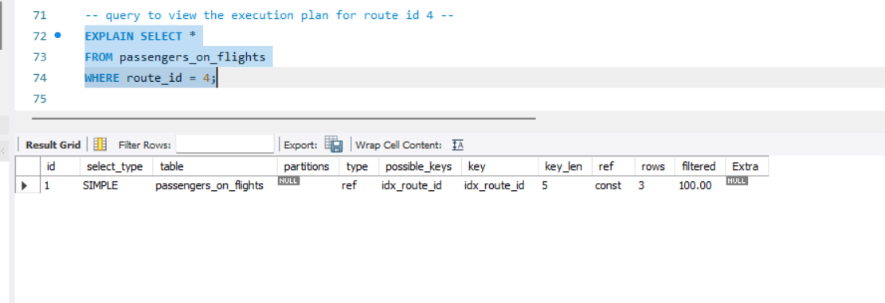

- Write a query to calculate the total price of all tickets booked by a customer across different aircraft IDs using the rollup function.
SELECT
customer_id,
aircraft_id,
SUM(price_per_ticket) AS total_price
FROM
ticket_details
GROUP BY
customer_id, aircraft_id WITH ROLLUP;
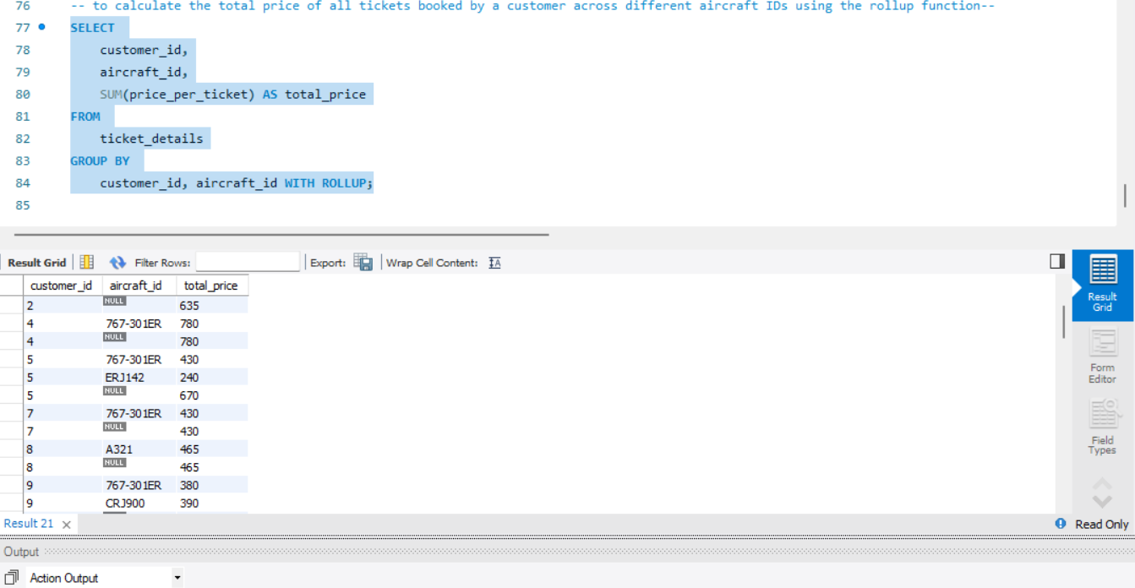

- Write a query to create a view with only business class customers and the airline brand.
CREATE VIEW business_class_customers AS
SELECT
customer_id,
brand
FROM
ticket_details
WHERE
class_id = 'Business';
SELECT * FROM business_class_customers;
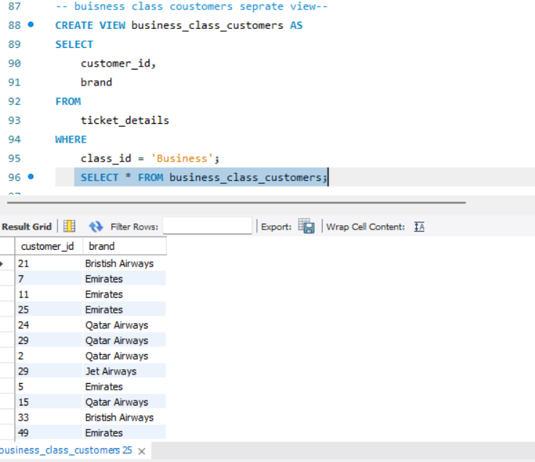

- Write a query to create a stored procedure that extracts all the details from the routes table where the traveled distance is more than 2000 miles.
DELIMITER //
CREATE PROCEDURE GetLongRoutes()
BEGIN
SELECT *
FROM routes
WHERE distance_miles > 2000;
END //
DELIMITER ;
CALL GetLongRoutes();
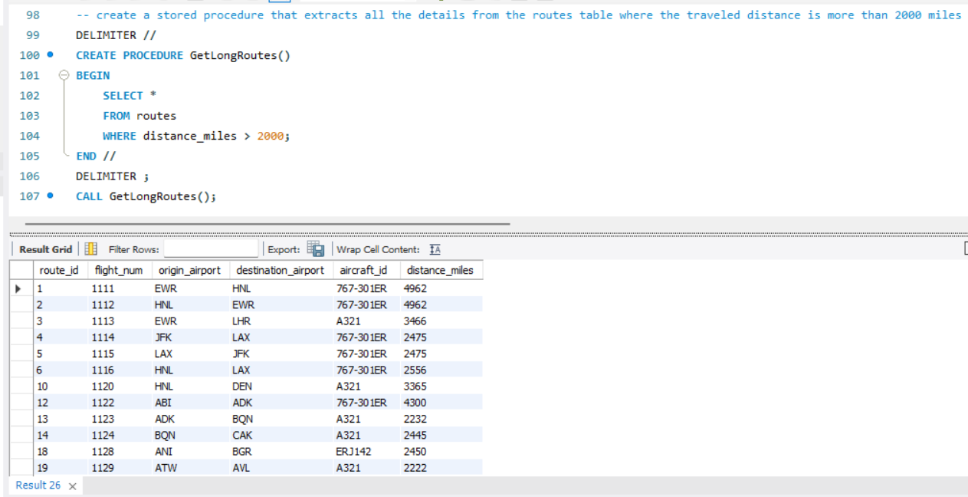

- Using GROUP BY, determine the total number of tickets purchased by each customer and the total price paid.
SELECT
customer_id,
COUNT(*) AS total_tickets,
SUM(price_per_ticket) AS total_amount_paid
FROM
ticket_details
GROUP BY
customer_id;
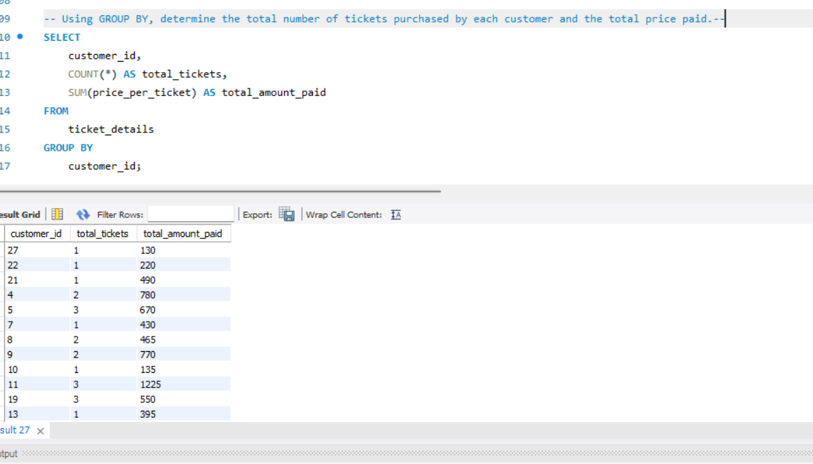

- Calculate the average distance and average number of passengers per aircraft, considering only those routes with more than one departure date.

SELECT r.aircraft_id,
AVG(r.distance_miles) AS avg_distance,
AVG(pf.passenger_count) AS avg_passengers
FROM (SELECT
route_id,
COUNT(DISTINCT travel_date) AS departure_count,
COUNT(customer_id) AS passenger_count
FROM
passengers_on_flights
GROUP BY
route_id
HAVING
COUNT(DISTINCT travel_date) > 1) pf
JOIN routes r ON pf.route_id = r.route_id
GROUP BY r.aircraft_id;
